**Smart Weather Monitoring System using ESP32**

# Objective

To build a smart weather monitoring system that senses temperature, humidity, hydrogen gas concentration, and rain levels using ESP32. The data is displayed on an I2C LCD and alerts are provided via a buzzer and LED.

# Components Used

1. ESP32 Development Board ( Also a Type C cable OR Micro Usb Cable, as per your Esp32 Port)  
2. DHT11 Temperature and Humidity Sensor  
3. MQ-8 Hydrogen Gas Sensor  
4. Rain Sensor Module  
5. I2C 16x2 LCD Display  
6. Buzzer  
7. LED  
8. Jumper Wires  
9. Breadboards  
10. Power Bank (Optional for portability)

# Wiring Details

|  |  |  |  |
| --- | --- | --- | --- |
| **Component** | **Pin on Component** | **Connect to ESP32 GPIO** | **Notes** |
| DHT11 | VCC | 3.3V | Power |
| GND | GND | Ground |
| DATA | GPIO 4 | Data output |
| MQ-8 Gas Sensor | VCC | 5V | Requires 5V |
| GND | GND | Ground |
| AO | GPIO 35 | Analog gas reading |
| Rain Sensor | VCC | 3.3V or 5V | Power supply |
| GND | GND | Ground |
| AO | GPIO 34 | Analog rain detection |
| Buzzer | + (VCC) | GPIO 14 | Buzzer control |
| - (GND) | GND | Ground |
| LED | Anode (+) | GPIO 26 | Use 220Ω resistor in series |
| Cathode (-) | GND | Ground |
| I2C LCD Display | VCC | 5V | Power |
| GND | GND | Ground |
| SDA | GPIO 21 | I2C data |
| SCL | GPIO 22 | I2C clock |

# Working Logic

- The DHT11 sensor provides temperature and humidity readings.  
- The MQ-8 sensor measures hydrogen gas levels. If the analog value exceeds 2000, the buzzer and LED are triggered.  
- The Rain Sensor provides an analog value based on moisture level. Lower values indicate more water.  
- An I2C LCD displays the current temperature, humidity, gas sensor value, and rain sensor reading.

# Code Summary

#include "DHT.h"  
#include <Wire.h>  
#include <LiquidCrystal_I2C.h>  
  
#define DHTPIN 4  
#define DHTTYPE DHT11  
#define MQ8PIN 35  
#define RAINPIN 34  
#define BUZZER 14  
#define LED 26  
  
DHT dht(DHTPIN, DHTTYPE);  
LiquidCrystal_I2C lcd(0x27, 16, 2);  
  
void setup() {  
 Serial.begin(115200);  
 Wire.begin(21, 22);  
 dht.begin();  
 lcd.begin(16, 2);  
 lcd.backlight();  
 pinMode(BUZZER, OUTPUT);  
 pinMode(LED, OUTPUT);  
 lcd.setCursor(0, 0);  
 lcd.print("Weather Monitor");  
 delay(2000);  
 lcd.clear();  
}  
  
void loop() {  
 float temp = dht.readTemperature();  
 float hum = dht.readHumidity();  
 if (isnan(temp) || isnan(hum)) {  
 lcd.setCursor(0, 0);  
 lcd.print("DHT Read Error ");  
 delay(2000);  
 return;  
 }  
  
 int gasValue = analogRead(MQ8PIN);  
 int rainValue = analogRead(RAINPIN);  
  
 lcd.setCursor(0, 0);  
 lcd.print("T:"); lcd.print(temp, 1);  
 lcd.print(" H:"); lcd.print(hum, 1);  
 lcd.setCursor(0, 1);  
 lcd.print("G:"); lcd.print(gasValue);  
 lcd.print(" R:"); lcd.print(rainValue);  
  
 if (gasValue > 2000) {  
 digitalWrite(BUZZER, HIGH);  
 digitalWrite(LED, HIGH);  
 } else {  
 digitalWrite(BUZZER, LOW);  
 digitalWrite(LED, LOW);  
 }  
  
 delay(2000);  
}

# Thresholds

- Gas Sensor (MQ-8): Value > 2000 triggers buzzer and LED.  
- Rain Sensor: Dry ~1023, Wet ~300 (used for display only).

# LCD Output Format

# - Line 1: T:<temperature> H:<humidity> - Line 2: G:<gas_value> R:<rain_value> Output on LCD

Example:

T:27.0 H:65.0  
A:380 R:1023  
  
- T: Temperature in Celsius.  
- H: Humidity percentage.  
- A: Air quality analog value.  
- R: Rain sensor analog value

Project Prototype (Original Image)   
  
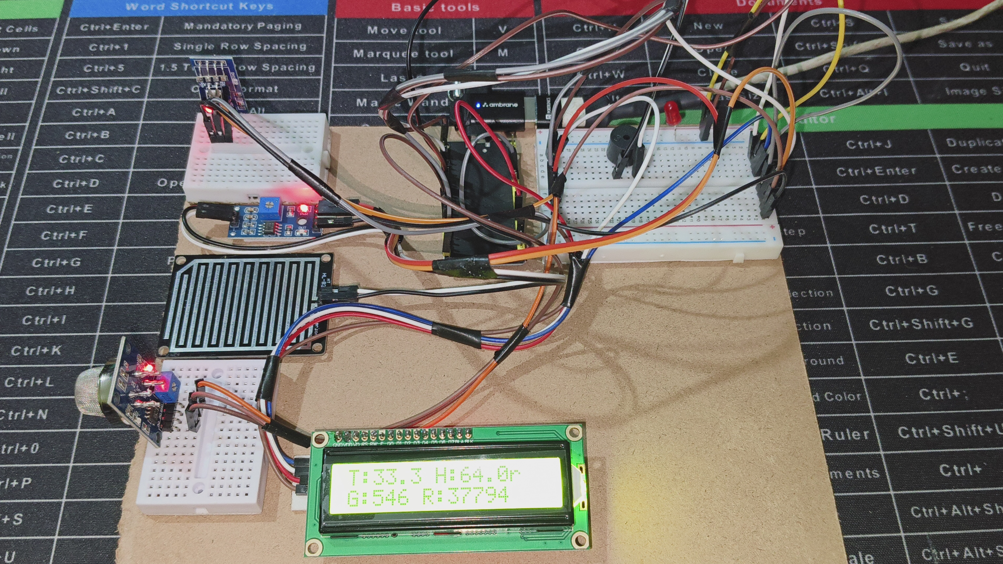  
**Notes**

1. Ensure all grounds (GND) are connected to the same rail.  
2. Confirm the I2C address of your LCD using an I2C scanner sketch.  
3. Use appropriate resistors to protect the LED and sensors.

**Result**

The system successfully monitors multiple environmental parameters and displays real-time data while alerting in case of high hydrogen gas presence.  
  
 **Summary**This project develops a smart weather monitoring system using an ESP32 microcontroller to track temperature, humidity, hydrogen gas levels, and rainfall. The system integrates a DHT11 sensor for climate data, an MQ-8 sensor for hydrogen detection, and a rain sensor for moisture measurement. Real-time readings are displayed on an I2C LCD, while a buzzer and LED provide alerts if gas levels exceed safe thresholds. The setup is powered via 3.3V/5V pins, with optional portability using a power bank. The system efficiently monitors environmental conditions, making it suitable for weather stations, safety alerts, and IoT applications.